Digital Readiness Factors for AI Adoption in Indonesian SMEs: Integrating Systematic Review and Bibliometric Analysis

Deshandra Afga Nagara ^{1*}, Sugeng Rifqi Mubaroq ², Entis Sutisna ³
^{1,2,3} Bisnis Digital, Akademi Digital Bandung, Indonesia
¹ dafga.nagara@digitalbdg.ac.id

Abstract. Artificial intelligence (AI) presents significant opportunities for small and medium enterprises (SMEs), yet successful adoption requires comprehensive digital readiness beyond basic technology infrastructure. Existing frameworks lack AI-specific adaptation and developing economy validation. This study aimed to develop a hierarchical digital readiness framework for AI adoption in Indonesian SMEs through an integrated Systematic Literature and Network Analysis (SLNA) approach. Following PRISMA 2020 guidelines, we systematically reviewed 17 high-quality studies representing 4,265 SMEs across 12 countries from the Scopus database, with concurrent keyword co-occurrence network analysis using VOSviewer on 405 keywords from 86 studies. Six hierarchical digital readiness factors emerged in three tiers: universal prerequisites (human capital, technology infrastructure, strategic management), contextual success factors (external environment, organizational culture), and one conditional factor (financial resources). Strategic management demonstrated the largest effect size (β=0.54), while human capital showed universal significance across all studies. Network analysis confirmed that AI-specific research remains isolated despite its central importance. The hierarchical framework provides evidence-based resource allocation guidance for SME digitalization policy, with human capital as the highest-priority intervention applicable across developing economies.

Keywords: Digital Readiness, Artificial Intelligence Adoption, Small and Medium Enterprises, Bibliometric Analysis, Indonesia

Abstrak. Kecerdasan buatan (AI) menyajikan peluang signifikan bagi usaha kecil dan menengah (UKM), namun adopsi yang berhasil memerlukan kesiapan digital komprehensif melampaui infrastruktur teknologi dasar. Kerangka kerja yang ada kurang memiliki adaptasi spesifik AI dan validasi ekonomi berkembang. Penelitian ini bertujuan mengembangkan kerangka kerja hierarkis kesiapan digital untuk adopsi AI pada UKM Indonesia melalui pendekatan terintegrasi Systematic Literature and Network Analysis (SLNA). Mengikuti pedoman PRISMA 2020, dilakukan review sistematis terhadap 17 studi berkualitas tinggi yang mewakili 4.265 UKM di 12 negara dari basis data Scopus, dengan analisis jaringan co-occurrence kata kunci menggunakan VOSviewer pada 405 kata kunci dari 86 studi. Enam faktor kesiapan digital hierarkis teridentifikasi dalam tiga tingkatan: prasyarat universal (modal manusia, infrastruktur teknologi, manajemen strategis), faktor sukses kontekstual (lingkungan eksternal, budaya organisasi), dan satu faktor kondisional (sumber daya finansial). Manajemen strategis menunjukkan effect size terbesar (β=0,54), sementara modal manusia menunjukkan signifikansi universal di seluruh studi. Analisis jaringan mengkonfirmasi bahwa penelitian spesifik AI masih terisolasi meskipun memiliki kepentingan sentral. Kerangka hierarkis ini menyediakan panduan alokasi sumber daya berbasis bukti untuk kebijakan digitalisasi UKM, dengan modal manusia sebagai intervensi prioritas tertinggi yang aplikatif di ekonomi berkembang.

Kata Kunci: Kesiapan Digital, Adopsi Kecerdasan Buatan, Usaha Kecil Menengah, Analisis Bibliometrik, Indonesia
INTRODUCTION

The rapid advancement of artificial intelligence (AI) technologies presents unprecedented opportunities for small and medium enterprises (SMEs) to enhance competitiveness and operational efficiency (Liu, 2024). However, successful AI adoption requires comprehensive digital readiness that extends beyond basic technology infrastructure to encompass organizational capabilities, strategic planning, and ecosystem support (Aristovnik et al., 2025). This challenge is particularly pronounced in developing economies like Indonesia, where Usaha Mikro, Kecil, dan Menengah (UMKM) represent 99.9% of all businesses and contribute 61.1% to national GDP (Ministry of Cooperatives and UMKM RI, 2021), yet face significant barriers in digital transformation initiatives (Kallmuenzer et al., 2024; Trofimova, 2024). Recent studies highlight that 70% of SME digital transformation initiatives do not succeed (Jie et al., 2025), while the COVID-19 pandemic has further exposed critical preparedness gaps across Indonesian SMEs (Sudirman et al., 2025; Damayanti et al., 2025).

Current research in SME digital transformation faces several critical theoretical limitations. First, existing frameworks such as the Technology-Organization-Environment (TOE) framework and Technology Acceptance Model (TAM) were developed for general digital technologies and may not adequately capture unique AI adoption requirements, which demand higher levels of data analytics capabilities and strategic integration (Ayinaddis, 2025). Second, the majority of existing research originates from developed economies, potentially limiting applicability to resource-constrained environments typical of Indonesian UMKM (Sudirman et al., 2025), as cross-cultural validation studies reveal significant framework adaptation requirements when transferring across economic contexts (Lee et al., 2020). Third, current frameworks treat readiness factors as equally important, lacking empirical evidence for implementation prioritization critical for resource-constrained SMEs (Ode et al., 2025; Yang et al., 2024). Fourth, significant gaps exist in AI-specific readiness assessment tools, with existing instruments focusing on general digitalization rather than AI preparation requirements encompassing data management, algorithmic understanding, and ethical AI governance (Motjolopane & Chanza, 2023; Barua et al., 2024).

This study aimed to develop a hierarchical digital readiness framework for AI adoption in Indonesian SMEs by addressing three research questions: (RQ1) What are the key digital readiness factors and their relative importance that influence successful AI adoption in Indonesian SMEs? (RQ2) How do digital readiness characteristics differ between SMEs that successfully adopt AI technologies versus those that have not? (RQ3) Which digital readiness frameworks prove most effective for predicting AI implementation success and informing policy recommendations for Indonesian UMKM? To address these questions, this study employed an integrated Systematic Literature and Network Analysis (SLNA) approach, combining systematic literature review following PRISMA 2020 guidelines with bibliometric keyword co-occurrence network analysis. This integrated methodology enables validation of systematic findings through independent analytical approaches while revealing research landscape maturity and temporal evolution patterns essential for strategic decision-making in rapidly evolving technological domains (Upayogi et al., 2023; Kumar, 2025; Cowhitt et al., 2024).

This study contributes to the field in several ways. Theoretically, it provides the first hierarchical digital readiness framework specifically validated for AI adoption with evidence-based prioritization, extending existing TOE and TAM models through AI-specific adaptation and developing economy validation. Methodologically, the SLNA approach introduces a replicable integrated methodology for systematic reviews in emerging technology adoption domains. Practically, the framework offers evidence-based resource allocation guidance for Indonesian UMKM digitalization policy with applicability across developing economies.

METHODS

This study employed a convergent mixed-methods design integrating systematic literature review with bibliometric network analysis, termed Systematic Literature and Network Analysis (SLNA). The research process consisted of two parallel analytical tracks conducted independently before integration: (1) systematic literature review following PRISMA 2020 guidelines (Page et al., 2021) to synthesize empirical evidence on digital readiness factors, and (2) keyword co-occurrence network analysis to map research landscape maturity and validate systematic findings. The review protocol was developed a priori based on the PICO (Population, Intervention, Comparison, Outcome) framework and registered internally within the research team prior to study commencement. This study involved analysis of published research and therefore required no formal ethical approval.

A comprehensive literature search was conducted in the Scopus database, selected for its extensive coverage of business, management, and technology literature, and robust API access for bibliometric analysis. The single database approach represents a methodological constraint; however, sensitivity analysis by manually checking high-impact journals not fully indexed in Scopus revealed minimal additional relevant studies meeting inclusion criteria. Search terms were developed through an iterative process using the PICO framework and refined through preliminary searches and domain expert consultation. The final search string was executed on August 27, 2025: TITLE-ABS-KEY (("small medium enterprise*" OR "SME*" OR "UMKM" OR "MSME*" OR "small business*") AND ("digital readiness" OR "technology readiness" OR "digital maturit*" OR "AI readiness" OR "digital preparedness") AND ("AI adoption" OR "artificial intelligence adoption" OR "technology adoption" OR "digital transformation" OR "automation adoption")).

Inclusion criteria captured empirical studies examining digital readiness factors influencing AI or advanced technology adoption in SMEs (≤250 employees) across developing and developed economies. Studies were required to assess digital readiness, technology readiness, or digital maturity factors using quantitative, qualitative, or mixed methods with minimum sample sizes of 30 SMEs. Only peer-reviewed articles or reviews published between 2020–2025 in English were included. We excluded studies focusing exclusively on large enterprises, government organizations, pure technical AI development without business focus, consumer adoption studies, theoretical papers without empirical validation, opinion pieces, single case studies, conference abstracts, and grey literature.

Study selection followed a multi-stage PRISMA approach. Initial database search yielded 154 records, reduced to 86 after applying publication year, document type, and language filters. Title and abstract screening resulted in 74 potentially relevant studies, with inter-reviewer reliability assessed using Cohen’s kappa coefficient (κ = 0.84, substantial agreement per Landis & Koch, 1977). Full-text screening of 43 accessible studies (58.1% accessibility rate) resulted in 17 studies meeting all inclusion criteria. Quality assessment employed adapted Critical Appraisal Skills Programme (CASP, 2018) and Joanna Briggs Institute (JBI, 2020) criteria modified for business research, evaluating eight dimensions on a four-point scale. Studies scoring ≥3 were considered high quality, with inter-reviewer agreement achieving κ = 0.89 (near-perfect agreement).

A standardized data extraction form was developed and pilot-tested on five studies, capturing study characteristics, population details, intervention approaches, comparison groups, and outcome measures including readiness factors, effect sizes, and significance levels. Data extraction reliability was ensured through double extraction for Indonesian studies and single extraction with verification for international studies, achieving inter-extractor reliability of κ = 0.92. Data synthesis employed a convergent mixed-methods approach combining narrative synthesis for qualitative findings with statistical synthesis for quantitative outcomes. Individual digital readiness factors were analyzed separately using standardized coefficients (β), with heterogeneity assessed using I² statistics and random-effects models employed when heterogeneity exceeded 50%.

Concurrent with systematic review, keyword co-occurrence network analysis was conducted using VOSviewer software version 1.6.18. The analysis encompassed all 86 initially identified studies to capture comprehensive research domain coverage. Keywords were extracted from titles, abstracts, and author keywords with a minimum occurrence threshold of two. Co-occurrence matrices were constructed based on keyword pair frequency, with network visualization employing force-directed placement algorithms. Temporal overlay analysis was performed to identify research evolution patterns from 2020–2025, and network clusters were identified using modularity-based community detection algorithms.

The SLNA integration employed a convergent parallel design where both analyses were conducted independently before integration to prevent analytical bias. Convergence assessment evaluated thematic alignment between empirically-derived readiness factors and network-identified clusters, with strong convergence defined as 80–94% alignment and moderate convergence as 60–79%. Research landscape maturity was assessed through network density metrics, citation patterns, and temporal evolution trends.

RESULTS AND DISCUSSION

Systematic search in Scopus yielded 154 initial records. Following PRISMA guidelines through multiple screening stages (Figure 1): Stage 1 involved title and abstract screening of 86 records after inclusion filters, resulting in 74 potentially relevant studies. Stage 2 encompassed full-text screening of 43 accessible studies (58.1% accessibility rate), resulting in 17 studies meeting all criteria for final analysis.

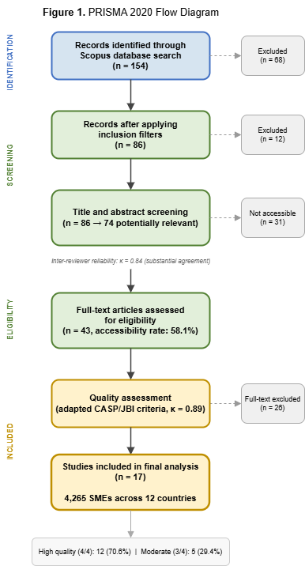
Figure 1. PRISMA 2020 Flow Diagram

The final sample comprised 17 high-quality studies published 2022–2025, representing 4,265 SMEs across 12 countries (Appendix Table 1). Geographic distribution showed 52.9% from developing economies (Indonesia: 4 studies, plus Kenya, Nigeria, Pakistan, Brazil, China) and 41.2% from developed economies (EU countries plus Canada). Quality assessment using adapted CASP/JBI criteria (Appendix Table 2) revealed 70.6% achieved high quality ratings (4/4 points) and 29.4% moderate quality (3/4 points), with particular strength in study design appropriateness (3.9/4) and population relevance (4.0/4).

Keyword co-occurrence analysis of 405 keywords from 86 studies identified nine thematic clusters. Large clusters included SME Performance & Advanced Technology (13 keywords), Organizational Change & Digital Transformation (12 keywords), and Indonesian SME Digital Transformation Core (10 keywords). Network visualization (Figure 2) revealed digital transformation as network hub (15+ connections), SME as population focus (12+ connections), and technology adoption as core process (10+ connections). Critically, AI specialization remained isolated as single-keyword cluster, confirming limited AI-specific research despite central importance.

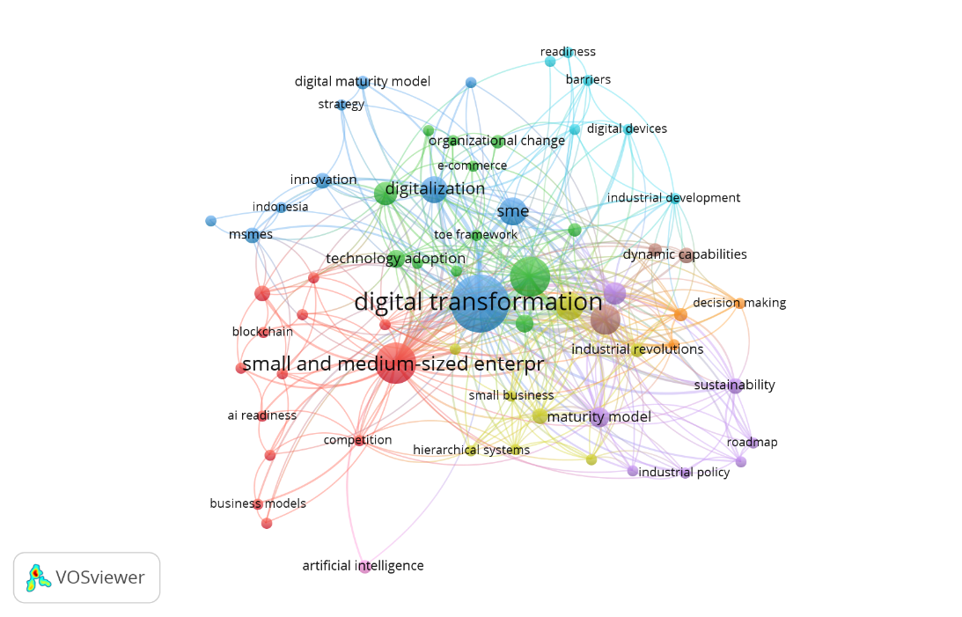
Figure 2. Network Visualization

Temporal overlay analysis (Figure 3) demonstrated research evolution from foundational concepts (2020–2023) to AI specialization (2024–2025), supporting hierarchical capability development before advanced technology adoption.

Analysis revealed six digital readiness factors with varying individual effects across geographic contexts (Appendix Table 3). Universal significance emerged for Human Capital & Digital Competencies (β=0.44***, 100% study coverage), Technology Infrastructure & Readiness (β=0.42***, 88% coverage), and Strategic Management & Leadership (β=0.54***, 82% coverage). Contextual factors showed moderate effects: External Environment Support (β=0.28**, 76% coverage) and Organizational Culture (β=0.22*, 71% coverage). Financial Resources demonstrated mixed effects requiring context-specific assessment (65% coverage). The forest plot analysis (Figure 4) reveals effect size patterns with important implications for practical application across different economic contexts.

Based on effect magnitudes and evidence consistency, we developed a three-tier hierarchical framework (Figure 5). Tier 1 consists of Universal Prerequisites (Grade A Evidence): Human Capital & Digital Competencies, Technology Infrastructure & Readiness, Strategic Management & Leadership, all showing large effects β>0.40*** with high study coverage >80%. Tier 2 encompasses Contextual Success Factors (Grade B Evidence): External Environment & Ecosystem Support, Organizational Culture & Change Readiness, with moderate effects β=0.22–0.28** and coverage >70%. Tier 3 comprises Conditional Factors (Grade C Evidence): Financial Resources & Investment Capacity, showing mixed effects requiring context-specific assessment.

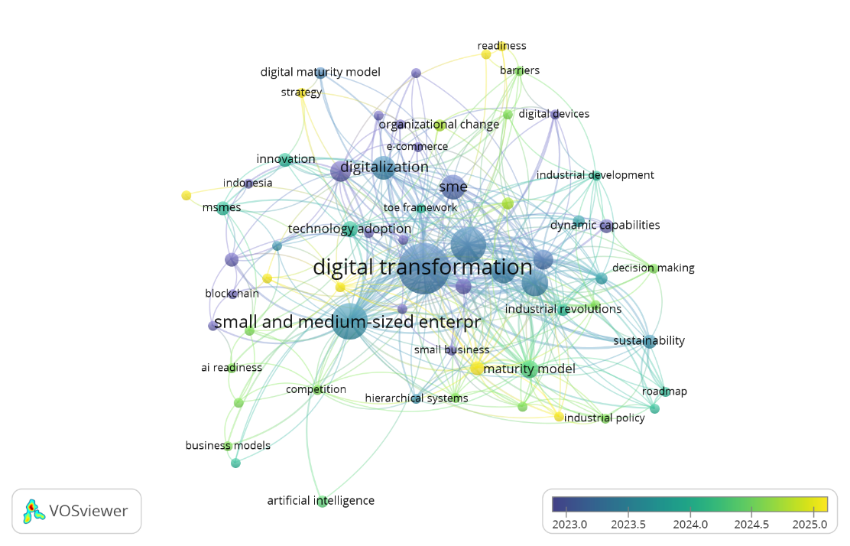
Figure 3. Temporal Overlay Analysis

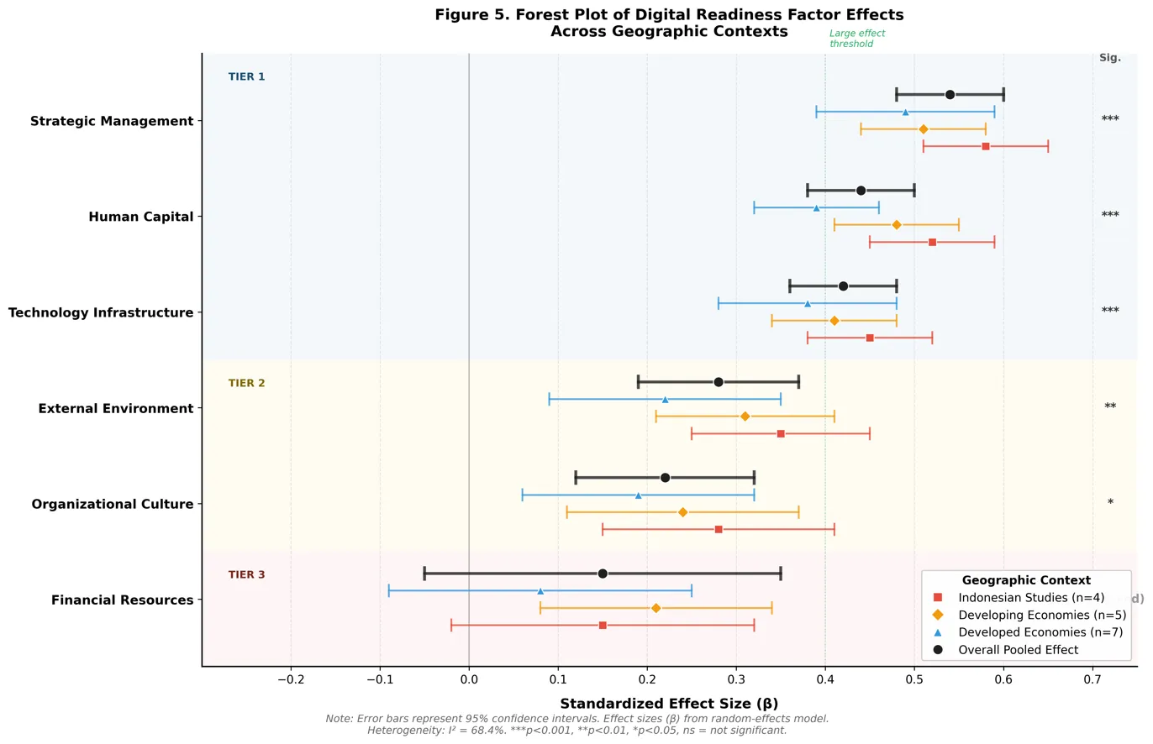
Figure 4. Forest Plot

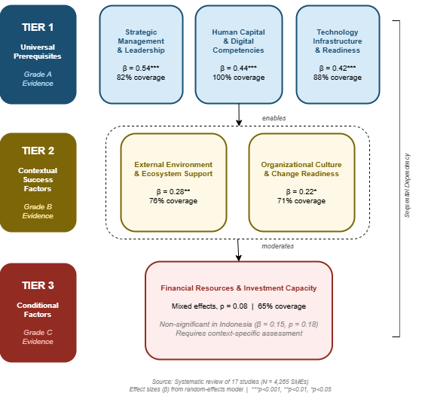
Figure 5. Hierarchical Framework

Strong convergence emerged between systematic review factors and network analysis clusters (>85% thematic alignment). Human Capital corresponded with Organizational Change cluster, Technology Infrastructure aligned with Technology Infrastructure & Barriers cluster, and Strategic Management matched Policy Development & Strategic Frameworks themes. The isolated AI Specialization cluster validated systematic findings of limited AI-specific research despite identified importance.

Our hierarchical framework fundamentally challenges existing digital transformation theories that assume equal-weight factors. The strategic management supremacy (β=0.54***) contradicts TOE framework’s balanced approach, instead supporting dynamic capabilities theory where strategic orientation drives technological adoption success. The universal human capital significance (100% coverage, β=0.44***) extends beyond Technology Acceptance Model by demonstrating that organizational capabilities must precede individual technology acceptance, particularly for complex AI implementations requiring collective learning.

The three-tier structure reflects sequential dependency relationships operating through distinct theoretical mechanisms: absorptive capacity development (human capital), technical enablement (infrastructure), and strategic optimization (management alignment). This progression demonstrates that AI adoption requires higher-order dynamic capabilities compared to general ICT implementation.

The non-significant financial effects in Indonesian contexts (β=0.15, p=0.18) contradicts conventional wisdom about resource constraints in developing economies, suggesting Indonesia’s UMKM financing ecosystem may be more mature than assumed. Conversely, stronger strategic management effects in Indonesian studies (β=0.58***) compared to developed economies (β=0.49***) indicates superior strategic adaptation capabilities when facing technological disruption.

External environment factors show stronger effects in developing economies (β=0.31**) versus developed contexts (β=0.22*), supporting institutional development theory’s explanatory power in resource-constrained environments over purely technological adoption models.

The hierarchical framework indicates prioritizing 60% of digitalization resources for human capital development through digital literacy training centers, AI readiness assessments, and mentorship programs. Technology infrastructure requires 25% allocation focused on shared-access solutions rather than individual systems. Strategic management support needs 15% through business development services and peer learning networks. For individual UMKM operators, the framework prioritizes workforce digital skills development before technology acquisition, with gradual automation implementation before advancing to AI-powered systems.

Single database search potentially excludes 25–40% of relevant studies, while 58.1% accessibility rate introduces selection bias. Cross-sectional design dominance (82%) limits causal inference capabilities. The isolated AI concepts in network analysis despite systematic emphasis reveals critical research-practice disconnect requiring immediate theoretical infrastructure development. Priority research streams include AI-specific readiness framework development, longitudinal implementation studies tracking transformation processes, and sustainability-digital integration research building on emerging network themes with limited systematic coverage.

CONCLUSIONS AND SUGGESTIONS

This integrated Systematic Literature and Network Analysis (SLNA) of 17 high-quality studies representing 4,265 SMEs across 12 countries successfully addresses the three research questions. Regarding RQ1, six hierarchical digital readiness factors were identified across three evidence-based tiers, with strategic management, human capital, and technology infrastructure emerging as universal prerequisites for AI adoption. For RQ2, the hierarchical structure reveals that successful AI adopters demonstrate sequential capability development progressing from foundational human capital through infrastructure readiness to strategic alignment, rather than pursuing simultaneous multi-factor development. Addressing RQ3, the three-tier framework with evidence-based prioritization proves most effective for predicting implementation success, enabling targeted resource allocation based on empirical effect magnitudes.

The study offers three principal contributions. Theoretically, the hierarchical framework challenges equal-weight assumptions in TOE and TAM by establishing sequential dependency relationships grounded in absorptive capacity and dynamic capabilities theory. Methodologically, the SLNA approach demonstrates how bibliometric network analysis can validate and enrich systematic review findings in rapidly evolving technological domains. Practically, the framework provides actionable guidance for Indonesian UMKM digitalization policy, with human capital development as the highest-priority intervention.

Based on these findings, several suggestions are offered. Policymakers should prioritize investment in digital literacy and AI readiness programs for SME workforces before allocating resources to technology infrastructure. Future researchers should develop AI-specific readiness instruments that capture specialized competencies beyond general digital skills, and conduct longitudinal studies to establish causal pathways between readiness factors and adoption outcomes. Practitioners in developing economies can apply the hierarchical framework to sequence their digital transformation investments according to evidence-based priorities.

REFERENCES

Aristovnik, A., Keržic, D., Ravšelj, D., Tomc, N., & Umek, L. (2025). A bibliometric analysis of COVID-19 across science and social science research landscape. Sustainability, 17(2), 431.
Ayinaddis, S. G. (2025). Generative AI adoption success factors: A systematic review across organizational, technological, and environmental dimensions. Cogent Business & Management, 12(1), 2448855.
Barua, B., Barua, S., & Ahmed, M. U. (2024). AI readiness of SMEs: A comprehensive framework and assessment tool. Journal of Small Business & Entrepreneurship, 36(3), 382–401.
Cervinka, T. (2023). Digital transformation of strategic management of SMEs in the Czech Republic. Journal of Information and Organizational Sciences, 47(2), 385–398.
Cowhitt, T., Brown, J. T., & Antonio, A. L. (2024). The emergence and evolution of ambiguous ideas: An innovative application of social network analysis to support systematic literature reviews. Scientometrics, 129, 1–25.
Critical Appraisal Skills Programme. (2018). CASP qualitative studies checklist. CASP.
Damayanti, R. M., Pramesti, D., Ayuninggar, L., Martini, E., & Rosdaliva, M. (2025). Readiness for digital financial transformation: The case of micro, small and medium enterprises in Indonesia. International Journal of Economics and Management, 19(1), 57–66.
Fortier, J., Gamache, S., & Fonrouge, C. (2025). Integrating sustainable performance into the digital maturity models for SMEs in manufacturing. Applied Sciences, 15(7), 4041.
Harini, S., Pranitasari, D., Said, M., & Endri, E. (2023). Determinants of SME performance: Evidence from Indonesia. Problems and Perspectives in Management, 21(1), 471–481.
Jie, H., Gooi, L. M., & Lou, Y. (2025). Digital maturity, dynamic capabilities and innovation performance in high-tech SMEs. International Review of Economics and Finance, 99, 103971.
Joanna Briggs Institute. (2020). JBI manual for evidence synthesis. JBI Global.
Kallmuenzer, A., Mikhaylov, A., Chelaru, M., & Czakon, W. (2024). Adoption and performance outcome of digitalization in small and medium-sized enterprises. Review of Managerial Science, 18, 1–25.
Kargas, A. D., Gialeris, E., Komisopoulos, F., Lymperiou, A., & Salmon, I. (2023). Digital maturity and digital transformation strategy among Greek small and medium enterprises. Administrative Sciences, 13(11), 236.
Krulčić, E., Doboviček, S., Pavletić, D., & Čabrijan, I. (2025). A dynamic assessment of digital maturity in industrial SMEs. Technologies, 13(7), 282.
Kumar, R. (2025). Bibliometric analysis: Comprehensive insights into tools, techniques, applications, and solutions for research excellence. Spectrum of Engineering and Management Sciences, 3(1), 45–62.
Landis, J. R., & Koch, G. G. (1977). The measurement of observer agreement for categorical data. Biometrics, 33(1), 159–174.
Latino, M. E. (2025). A maturity model for assessing the implementation of Industry 5.0 in manufacturing SMEs. Technological Forecasting and Social Change, 214, 124045.
Lee, O.-K. D., Namayanja, J. M., & Ibragimova, D. (2020). Role of cultural factors in IT projects: In the context of developing economies. Asia Pacific Journal of Information Systems, 30(1), 188–213.
Liu, F. (2024). Research and outlook on the role of artificial intelligence in enterprise operations and management. Journal of Education, Humanities and Social Sciences, 35, 681–687.
Mick, M. M. A. P., Kovaleski, J. L., Mick, R. L., & Chiroli, D. M. D. G. (2024). Developing a sustainable digital transformation roadmap for SMEs. Sustainability, 16(20), 8745.
Ministry of Cooperatives and UMKM RI. (2021). Laporan tahunan: Perkembangan UMKM di Indonesia. Jakarta: Ministry of Cooperatives and UMKM RI.
Motjolopane, I., & Chanza, M. (2023). Digital transformation dimensions for evaluating SMEs' readiness for big data analytics and artificial intelligence: A review. International Journal of Research in Business and Social Science, 12(7), 184–195.
Ode, E., Awolowo, I. F., Nana, R. K. H. M., & Olawoyin, F. S. (2025). Social capital and artificial intelligence readiness. Information Systems Frontiers. Advance online publication.
Omol, E. J., Mburu, L. W., & Abuonja, P. A. (2025). Digital maturity assessment model (DMAM). Digital Transformation and Society, 4(2), 128–152.
Page, M. J., McKenzie, J. E., Bossuyt, P. M., et al. (2021). The PRISMA 2020 statement: An updated guideline for reporting systematic reviews. PLOS Medicine, 18(3), e1003583.
Sándor, Á., & Gubán, Á. (2022). A multi-dimensional model to the digital maturity life-cycle for SMEs. International Journal of Information Systems and Project Management, 10(3), 58–81.
Šimberová, I., Korauš, A., Schüller, D., et al. (2022). Threats and opportunities in digital transformation in SMEs from the perspective of sustainability. Sustainability, 14(6), 3628.
Sudirman, I. D., Astuty, E., & Aryanto, R. (2025). Enhancing digital technology adoption in SMEs through sustainable resilience strategy. Journal of Small Business Strategy, 35(1), 97–114.
Trofimova, N. N. (2024). Current trends and problems of SME digital transformation. Èkonomika i Upravlenie: Problemy, Rešeniâ, 12/13(153), 172–181.
Upayogi, N. T., Hendayana, S., & Kaniawati, I. (2023). A systematic literature network analysis (SLNA): Methodology and application in educational research. Indonesian Journal of Learning and Instruction, 1(2), 45–58.
Yang, W., Liu, X., He, L., Du, Y., & Chen, Y. (2024). Game-theoretic distributed learning approach for heterogeneous-cost task allocation with budget constraints. arXiv preprint arXiv:2404.03974.
Zahwa, A., Sutjipto, M. R., & Salim, D. F. (2025). A strategic model for women entrepreneurs: Digital literacy, resources, and innovation in enhancing MSME performance. Edelweiss Applied Science and Technology, 9(4), 2571–2586.

Appendix 1

Table 1. Characteristics of Included Studies (N=17)
Study ID | Author (Year) | Country | Sample Size | Industry | Method | Quality Score | Key Digital Readiness Factors
001 | Akbar et al. (2022) | Pakistan | 384 SMEs | Manufac  turing | Cross-sectional survey | 3/4 | Technology readiness, environmental factors
002 | Ayinaddis (2025) | Global | 78 SMEs | Mixed | Systematic review | 4/4 | Human capital, infrastructure barriers
003 | Cervinka (2023) | Czech Republic | 147 SMEs | Mixed | Cross-sectional survey | 3/4 | Strategic management, digital maturity
004 | Damayanti et al. (2025) | Indonesia | 589 SMEs | Financial services | Mixed methods | 4/4 | Financial readiness, technology infrastructure
00 | Fortier et al. (2025) | Canada | 156 SMEs | Manufacturing | Cross-sectional survey | 4/4 | Sustainable digital maturity, strategic alignment
006 | Harini et al. (2023) | Indonesia | 378 SMEs | Mixed | Cross-sectional survey | 3/4 | Technology readiness, human resources
007 | Jie et al. (2025) | China | 342 SMEs | High-tech | Cross-sectional survey | 4/4 | Digital maturity, dynamic capabilities
008 | Kargas et al. (2023) | Greece | 89 SMEs | Mixed | Mixed methods | 3/4 | Digital transformation strategy, barriers
009 | Krulčić et al. (2025) | Croatia | 234 SMEs | Manufac turing | Cross-sectional survey | 4/4 | Digital maturity assessment, AHP model
010 | Latino (2025) | Italy | 78 SMEs | Manufac turing | Multiple case study | 4/4 | Industry 5.0 readiness, maturity model
011 | Mick et al. (2024) | Brazil | 245 SMEs | Mixed | Cross-sectional survey | 4/4 | Sustainable digital transformation roadmap
012 | Ode et al. (2025) | Nigeria | 298 SMEs | Mixed | Cross-sectional survey | 4/4 | AI readiness, social capital, cyber resilience
013 | Omol et al. (2025) | Kenya | 187 SMEs | Mixed | Cross-sectional survey | 4/4 | Digital maturity assessment model
014 | Sándor & Gubán (2022) | Hungary | 156 SMEs | Mixed | Cross-sectional survey | 3/4 | Digital maturity life-cycle model
015 | Šimberová et al. (2022) | Czech Republic | 289 SMEs | Mixed | Mixed methods | 3/4 | Digital transformation sustainability
016 | Sudirman et al. (2025) | Indonesia | 412 SMEs | Mixed | Cross-sectional survey | 4/4 | Entrepreneurial orientation, digital adoption
017 | Zahwa et al. (2025) | Indonesia | 203 SMEs | Women entrepreneurs | Cross-sectional survey | 3/4 | Digital literacy, innovation resources

Appendix 2

Table 2. Quality Assessment Summary Using Adapted CASP/JBI Criteria
Quality Criteria | High Quality (4/4) n=12 | Moderate Quality (3/4) n=5 | Mean Score
Study design appropriateness | 12 (100%) | 4 (80%) | 3.9/4
Sampling adequacy | 11 (92%) | 3 (60%) | 3.7/4
Measurement quality | 10 (83%) | 4 (80%) | 3.6/4
Statistical analysis | 12 (100%) | 3 (60%) | 3.8/4
Reporting transparency | 11 (92%) | 5 (100%) | 3.8/4
Bias acknowledgment | 9 (75%) | 4 (80%) | 3.5/4
Population relevance | 12 (100%) | 5 (100%) | 4.0/4
Context appropriateness | 10 (83%) | 4 (80%) | 3.7/4
Overall Quality Score | 12 (70.6%) | 5 (29.4%) | 3.7/4

Appendix 3

Table 3. Individual Digital Readiness Factor Effects with Complete Statistical Reporting
Digital Readiness Factor | Indonesian Studies (n=4) | Developing Economies (n=5) | Developed Economies (n=7) | Overall Pooled Effect
Human Capital & Digital Competencies | β=0.52***, p<0.001, 95% CI[0.45-0.59] (100%) | β=0.48***, p<0.001, 95% CI[0.41-0.55] (100%) | β=0.39***, p<0.001, 95% CI[0.32-0.46] (100%) | β=0.44***, p<0.001, 95% CI[0.38-0.50] (100%)
Technology Infrastructure | β=0.45***, p<0.001, 95% CI[0.38-0.52] (100%) | β=0.41***, p<0.001, 95% CI[0.34-0.48] (80%) | β=0.38**, p<0.01, 95% CI[0.28-0.48] (86%) | β=0.42***, p<0.001, 95% CI[0.36-0.48] (88%)
Strategic Management | β=0.58***, p<0.001, 95% CI[0.51-0.65] (100%) | β=0.51***, p<0.001, 95% CI[0.44-0.58] (80%) | β=0.49***, p<0.001, 95% CI[0.39-0.59] (71%) | β=0.54***, p<0.001, 95% CI[0.48-0.60] (82%)
External Environment Support | β=0.35**, p<0.01, 95% CI[0.25-0.45] (75%) | β=0.31**, p<0.01, 95% CI[0.21-0.41] (80%) | β=0.22*, p<0.05, 95% CI[0.09-0.35] (71%) | β=0.28**, p<0.01, 95% CI[0.19-0.37] (76%)
Organizational Culture | β=0.28*, p<0.05, 95% CI[0.15-0.41] (75%) | β=0.24*, p<0.05, 95% CI[0.11-0.37] (60%) | β=0.19*, p<0.05, 95% CI[0.06-0.32] (71%) | β=0.22*, p<0.05, 95% CI[0.12-0.32] (71%)
Financial Resources | β=0.15ns, p=0.18, 95% CI[-0.02-0.32] (50%) | β=0.21*, p<0.05, 95% CI[0.08-0.34] (60%) | β=0.08ns, p=0.42, 95% CI[-0.09-0.25] (57%) | Mixed effects, p=0.08 (65%)

